
Market Research For Data Analytics Project

Porter is India’s leading intra-city & SME logistics platform that has scaled rapidly, reached unicorn valuation, returned to profitability, but is now tightening operations (headcount reductions) while facing gig-worker unrest and intense competition from both hyperlocal and tech-driven logistics players.

• Founded 2014; on-demand intra-city logistics (mini-trucks, vans, two-wheelers), packers & movers, and enterprise/light-logistics services.
• Rapid expansion across metros and Tier-2/3; significant two-wheeler push in 2025 to capture last-mile.
• Funding & valuation: entered the unicorn club with large Series F activity in 2025 (valuation ≈ $1.1–1.2B)

Current market & product trends affecting Porter
- Shift to two-wheeler & micro-logistics: faster, lower-cost last-mile moves; Porter has been doubling down on bike delivery to fight quick-commerce & hyperlocal players.
- Enterprise & SME demand for tech-enabled logistics: businesses want batching, SLAs, proof-of-delivery, analytics — not just raw capacity. Competitors are productizing B2B features.
- Unit-economics focus across industry: after funding winters, profitable growth matters — Porter’s move to profitability and headcount trim is consistent with investor demands.
- Regulatory & labor scrutiny for gig platforms (worker unions increasing activism and press scrutiny).

Top problems Porter is facing right now
- Labor / gig-worker unrest & reputational risk — Union letters and media reports flag exploitative conditions (fare drops, cancellations, suspensions). This can reduce driver supply and raise regulatory scrutiny.
- Operational restructuring & morale hit — layoffs (~300–350) create short-term disruption, possible loss of institutionally-knowledgeable staff and PR issues.
- Margin pressure from last-mile competition — two-wheeler push pits Porter against low-ticket, low-margin players (e.g., hyperlocal/quick commerce); keeping profitable while growing volume is tough.
- Competitive crowding & product feature race — rivals are adding B2B features (batching, analytics, SLAs), meaning Porter must invest in product to retain enterprise customers.
- Scaling complexity across vehicle types (bike → mini-truck → tempo → enterprise LTL): operational complexity raises fixed costs and increases the bar for tech & forecasting capabilities. (Industry sources on two-wheeler logistics growth & complexity.)

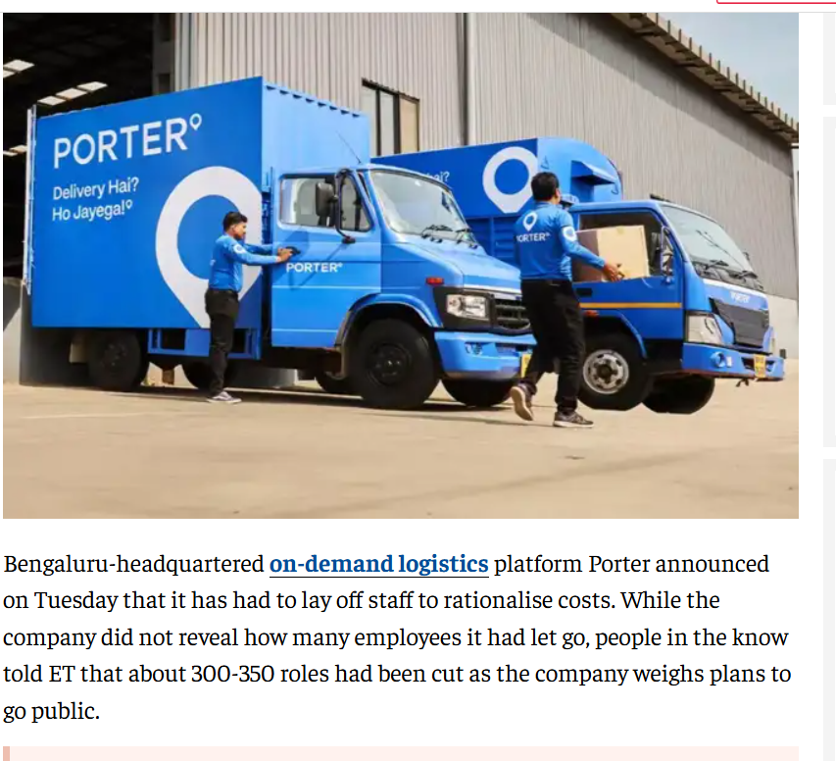

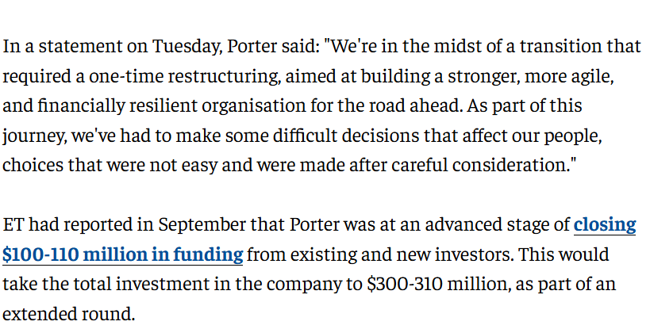

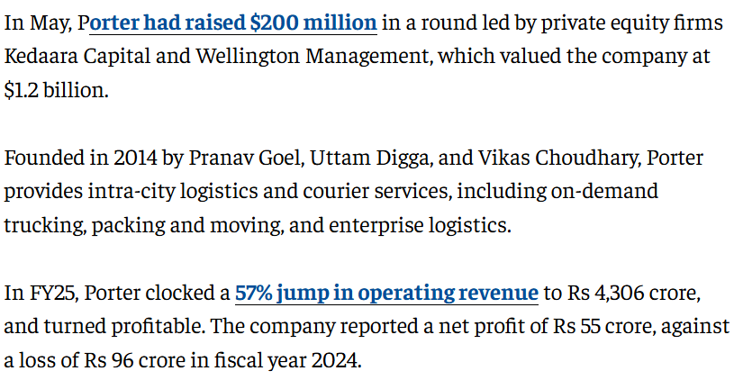

Based on recent reports, Porter, the Indian intra-city logistics unicorn, is facing a mix of operational, regulatory, and labor-related challenges despite achieving profitability and unicorn status in 2025.
Here are the key problems and challenges facing Porter nowadays:
- Mass Layoffs and Restructuring: As of November 2025, Porter laid off around 300–350 employees (roughly 18% of its workforce) across operations, tech, and support functions. This restructuring is aimed at reducing costs and streamlining operations ahead of a planned IPO, suggesting high operational expenses.
- Driver Exploitation and Labor Disputes: The Telangana Gig and Platform Workers Union (TGPWU) has accused Porter of "deteriorating and exploitative" working conditions. Key worker issues include:
  - Declining Pay: Steep drops in trip payouts, coupled with high fuel costs, have caused financial distress.
  - Unfair Suspensions: Drivers have complained about accounts being blocked without proper inquiry.
  - Lack of Benefits: Demands for mandatory cancellation charges, waiting charges, and better compensation are unresolved.
- Regulatory Hurdles and Legal Issues: The Karnataka transport department has registered cases against Porter for operating without proper goods carriage permits and displaying unauthorized advertisements on vehicles.
- Fraud and Safety Concerns:
  - Systemic Fraud: Delivery partners have exploited loopholes in the app to siphon off funds using geo-spoofing to create fake accounts, with one instance causing a ₹90 lakh loss.
  - Customer Complaints: Users have reported issues with packers and movers services, including damaged goods, unprofessional behavior, and difficulties in claiming compensation.
- Intense Competition and Margin Pressure: While profitable, Porter operates on thin margins (roughly 1.3% in FY25). It faces intense competition from established players like Delhivery, Shadowfax, and aggressive entry from Uber in the logistics space.
- High Operational Costs: Fleet costs represent 85% of their expenses, making them highly vulnerable to fuel price spikes and vehicle costs.
These challenges come at a critical time as the company tries to maintain profitability while scaling, having transitioned to two-wheelers for 60% of their orders

What Porter’s competitors are doing right now
- Productizing B2B features — Dunzo and others have been adding batching, account analytics, proof-of-delivery and SLA management for merchants — that increases wallet share and stickiness for enterprise customers.
- Global play & SME packaging (Lalamove) — Lalamove markets itself as an SME logistics partner with flexible vehicle sizes, international best practices and SME business packages.
- Hyperlocal specialization — Borzo, Shiprocket Quick and niche local players focus on low-ticket, high-frequency deliveries with optimized pricing and local driver pools to beat larger players on unit cost in specific geos.
- Diverse ticket mix (Delhivery / BlackBuck / Rivigo) — competitors balance B2C and B2B to smooth revenue cycles — e.g., combining parcel, marketplace fulfilment and longer-haul freight to diversify margins.

What Porter is doing well :
- Scale & multi-asset capability: Porter already runs trucks, vans, and bikes — that breadth lets it service everything from household moves to SME goods.
- Strong growth with path to profitability: FY25 revenue jump and reported profitability shows the model can be sustainable at scale.
- Investor confidence & capital availability (2025 funding): big rounds let Porter expand selectively while optimizing economics.

Where Porter is (or may be) underperforming —
- Gig worker relations & platform fairness — complaints about payout cuts, cancellations and suspensions risk driver shortages and regulatory action. Fix: publish transparent payout algorithms, create quick dispute resolution, guarantee minimum earnings in low demand periods.
- People & culture after layoffs — losing 300+ staff risks knowledge loss. Fix: targeted retention of high-value roles, clear comms, rehiring plan for growth functions.
- Product depth for enterprise clients — competitors are pushing analytics/SLAs; Porter must productize merchant dashboards, invoicing & API integrations. Fix: build modular B2B stack and a premium enterprise offering.
- Unit economics at micro-ticket levels — two-wheeler last-mile has low ASPs; Porter must optimize driver utilization and dynamic pricing to maintain margins. Fix: better batching, minimum order values, smart surge & subscription products.
- PR & regulatory preparedness — union letters and press require proactive external affairs and compliance playbooks. Fix: appoint a dedicated labor relations & compliance lead, run joint workshops with driver unions.

SWOT :
- Strengths: Multi-asset fleet, scale, recent profitability, deep investor backing.
- Weaknesses: Gig worker grievances, restructuring pain, unit economics for low-ticket segments.
- Opportunities: Enterprise logistics (SaaS & SLAs), ecommerce partnerships, subscription/retainer models, geographic penetration into Tier-2/3 cities.
- Threats: Agile hyperlocal rivals, regulatory/labour action, margin compression from price wars.

Tactical & strategic recommendations (prioritized, with KPIs)

Immediate (0–90 days)
- Driver relations triage — create a public driver-earnings dashboard and a 48-hour dispute resolution SLA. KPI: driver churn ↓ 25% in 3 months; driver NPS +15.
- Stabilize critical headcount — hire/backfill only for revenue-impact roles (ops, partner success, platform). KPI: time-to-hire for critical roles <45 days.
- Enterprise product sprint — ship merchant dashboard (POD, invoices, SLAs) + API integrations for top 50 SME clients. KPI: ARPU for enterprise customers +20% in 6 months.

Mid (3–9 months)
- Batching & utilization engine — rollout improved batching for micro-tickets to boost earnings per driver hour. KPI: driver utilization rate +18%.
- Tiered pricing / subscriptions — launch merchant subscriptions and guaranteed pickup windows (premium SKU). KPI: subscription adoption 8–12% of SME base.

Long (9–18 months)
- Verticalize for key industries — build tailored solutions (F&B, home-appliances, ecommerce sellers). KPI: vertical revenue share 35%.
- Transparency & compliance program — publish annual platform labor report and set up worker councils. KPI: reduction in formal complaints by 60%.

Porter has an active **logistics network in ~22 Indian cities, including big metro and Tier-1 locations like:
- Mumbai (Maharashtra) 2. Delhi / Delhi-NCR (Delhi & surrounding) 3. Bangalore Bengaluru (Karnataka) 4. Hyderabad (Telangana) 5.Chennai (Tamil Nadu) 6.Ahmedabad (Gujarat) 7. Pune (Maharashtra) 8. Surat (Gujarat) 9. Jaipur (Rajasthan) 10. Kolkata (West Bengal) 11.Chandigarh (Punjab / UT) 12. Coimbatore (Tamil Nadu) 13. Indore (Madhya Pradesh) 14. Lucknow (Uttar Pradesh) 15 .Vadodara (Gujarat) 16. Calicut / Kozhikode (Kerala) 17.Tiruppur (Tamil Nadu) 18. Rajkot (Gujarat)
The below cities are backed by Porter expansion reporting and/or service availability trends (these have been mentioned in various Porter service announcements, in credible expansion coverage and are consistent with the ~22-city footprint statement):
- Thiruvananthapuram (Kerala)
- Visakhapatnam (Andhra Pradesh)
- Nagpur (Maharashtra)
- Kanpur (Uttar Pradesh)

Company | FY-scale (latest reported) | Market-share estimate (India, range) | Core strengths / focus
Delhivery | Revenue ≈ ₹9,800–10,000 Cr (FY25 consolidated) | ~14–21% of express/online parcel market (range depends on inclusion of Ecom Express acquisition & measure used) | Largest integrated private CEP player, broad pin-code coverage, strong tech & fulfilment.
Blue Dart | Revenue ≈ ₹6,000+ Cr (FY25 / trailing) | ~10–36% (air-express / premium express share high; overall land + air share lower—Blue Dart cites large share in organized air- expres | Premium air express, strong SLA performance, deep B2C & timed delivery for high-value shipments.
DTDC | Revenue ≈ ₹2,400–2,500 Cr (FY25 reported) | ~5–10% (large pan-India ground network, strong in Tier-2/3 and franchise model; share varies by metric) | Extensive franchise network, strong local reach, growing e-commerce share.
Shadowfax | Revenue ≈ ₹2,400–2,500 Cr (reported on public filings / financial sites) | ~3–8% (fastest-growing 3PL in last-mile; share concentrated in quick commerce / hyperlocal segments | Strong 2W last-mile capability, e-commerce & quick-commerce focus, tech for route & batching.
Shiprocket | Revenue ≈ ₹1,632 Cr (FY25); losses narrowing | Platform/aggregator share: hard to express as single CEP share — platform processes large merchant volumes; platform revenue share smaller than carrier volumes. Use platform GMV or merchant shipments to compare. | Aggregator/tech stack for D2C brands — multi-courier routing, billing & merchant tools; strong in SaaS + logistics enablement.

